Lantern Festival

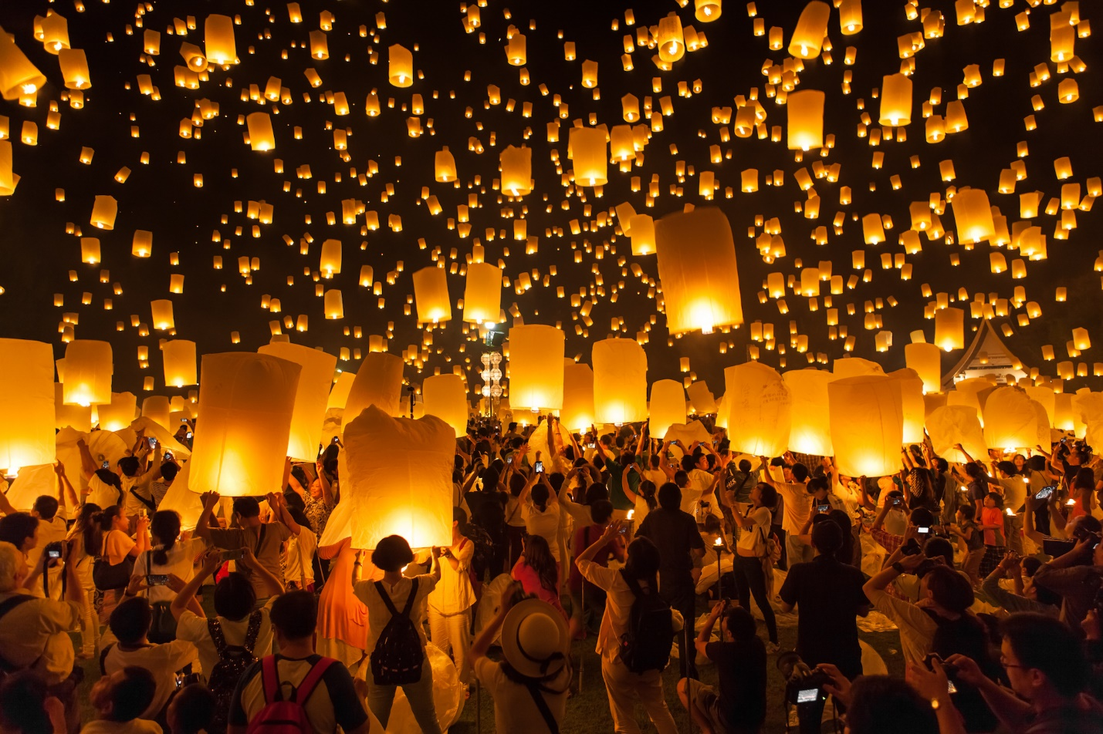

Lantern Festival is one of the most traditional festivals in China celebrated on the 15th day of the first month of the Chinese lunar year. It is a ‘festival within a festival' that is considered as the end of Spring Festival (Chinese New Year).

On the night of the festival, temples and businesses are decorated with colorful lanterns made of paper, gauze and glass, painting with legendary figures, landscapes as well as the flowers and birds. There are also the performances of drums and dragon dance in the street and lanes. On the day, people will eat sweet round dumplings made of glutinous rice flour filled with various kinds of fillings. The snack is called Yuanxiao in Chinese, so the festival is also named the Yuanxiao Festival.

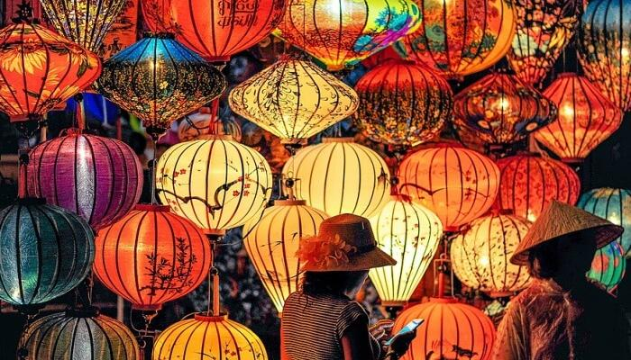

On the day, people will eat sweet round dumplings made of glutinous rice flour filled with various kinds of fillings. The snack is called Yuanxiao in Chinese, so the festival is also named the Yuanxiao Festival.

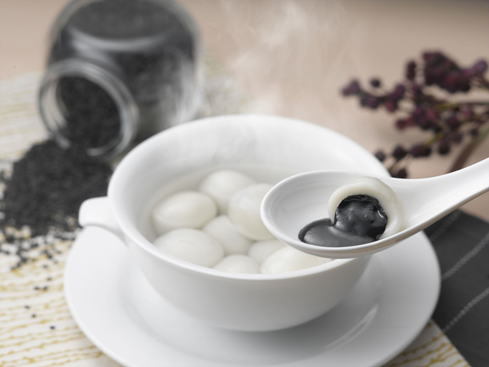

At the night of the festival, temples and parks are decorated with colorful lanterns made of paper, gauze and glass, painting with legendary figures, landscapes as well as the flowers and birds. After eating dinner, Chinese people like to walk around park to enjoy beautiful lanterns.

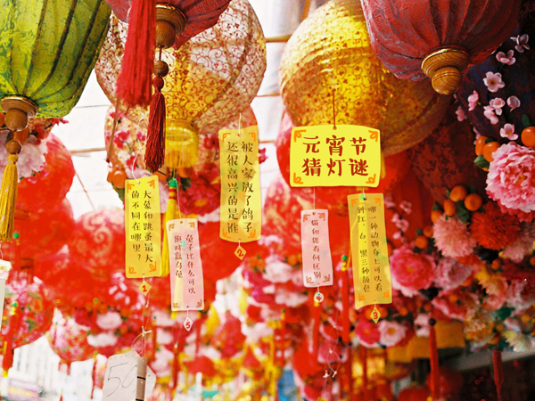

In southern China, especially Canton and Guangxi, there are also some dragon dance performance in the street and lanes. Where there is a dragon dance, where the people immerse in joyous atmospheres.

At present, most lantern festivals are held in public parks in cities and towns. People will have the riddles written on the lanterns. It will be the great fun to have a guess. The lanterns are more varied and colorful.